.

Electron
1- First npm init
2- npm install –save electron
3-
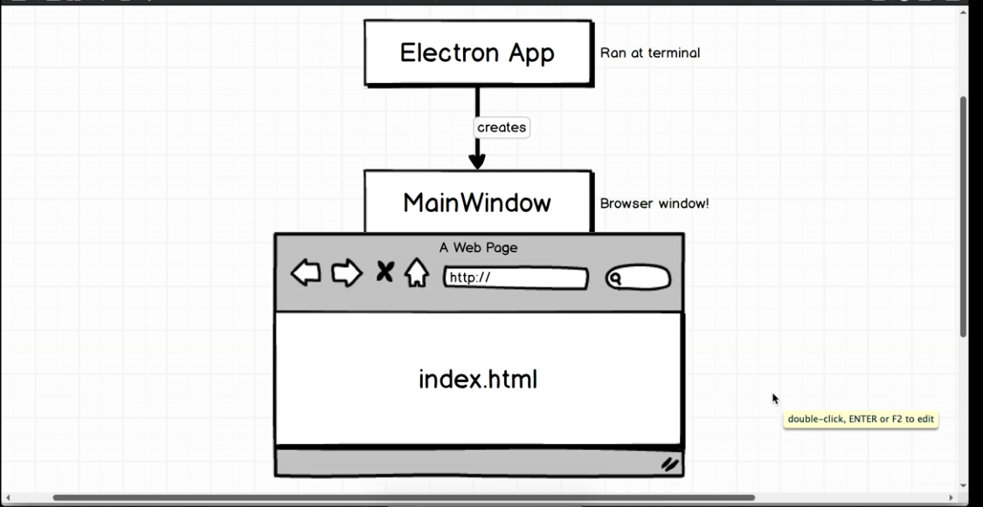
We will make 2 files
first for electron app and main window and second for index.html

create index.js in root of the app

4 -
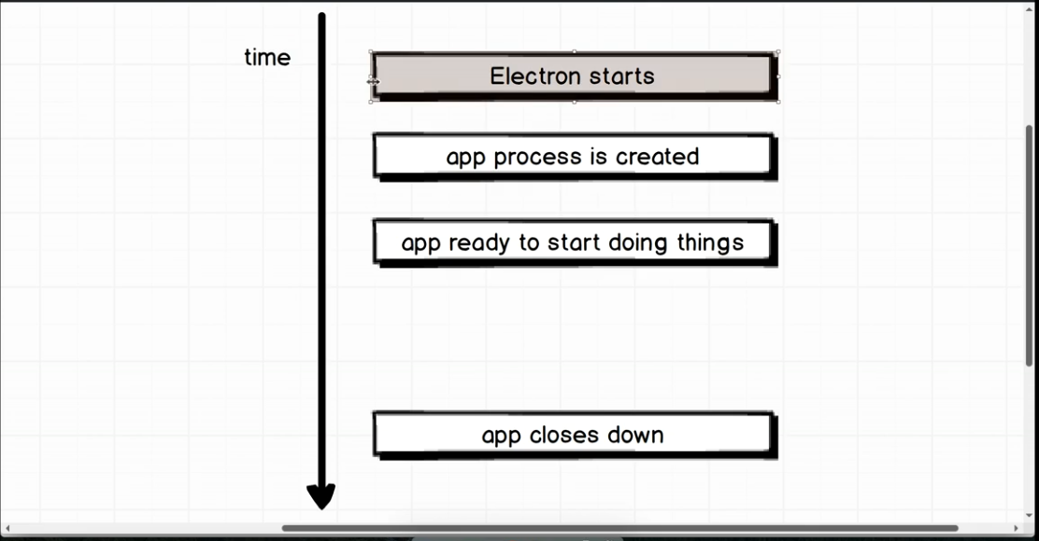

5 – Basic App
const electron = require('electron');

// Create main app object variable from electron
const {app} = electron;

// Wait for app to be ready before executing some code
app.on('ready', () => {
console.log('App is now ready');
})

6 – Add to package.json to start electron app
"scripts": {
"electron": "electron ."
},

here electron dot means to start electron in current directory

7 – To run app
npm run electron

8 - Now lets create a new browser window to display something on screen
to do that first import
const {app,BrowserWindow} = electron;

app.on('ready', () => {
new BrowserWindow({})
})

then npm run electron to see window, we will call this main window

Note – Electron app in above diag is index.js file and Main window is browser window which we just created , consider this as two seperate process though our index.js file creates browser window

The app module is used to control your application’s event lifecycle while the BrowserWindow module is used to create and control browser windows.

9 – Now lets create a simple html file and instruct our main window to load it
eg -
index.html -
<!DOCTYPE html>
<html lang="en">
<head>
<meta charset="UTF-8">
<meta name="viewport" content="width=device-width, initial-scale=1.0">
<meta http-equiv="X-UA-Compatible" content="ie=edge">
<title>Document</title>
</head>
<body>
<h1>Video Info</h1>
</body>
</html>

index.js -

const electron = require('electron');

// Create main app object variable from electron
const {app,BrowserWindow} = electron;

// Wait for app to be ready before executing some code
app.on('ready', () => {
const mainWindow = new BrowserWindow({});
//Below we can write www.google.com etc or local file using file protocol
mainWindow.loadURL(`file://${__dirname}/index.html`);
})

10 – When we make changes in code press ctrl + r to reload app or select refresh from options above

11 - Write script tag and dom manipulations like js
eg -
<!DOCTYPE html>
<html lang="en">
<head>
<meta charset="UTF-8">
<meta name="viewport" content="width=device-width, initial-scale=1.0">
<meta http-equiv="X-UA-Compatible" content="ie=edge">
<title>Document</title>
</head>
<body>
<h1>Video Info</h1>
<form>
<div>
<label>Select a Video Akash</label>
<input type="file" accept="video/*">
</div>
<button type="submit">Get Info</button>
</form>

<script>
document.querySelector("form").addEventListener("submit",(event) => {
event.preventDefault();
const file = document.querySelector("input").files[0]
})
</script>
</body>
</html>

12 -
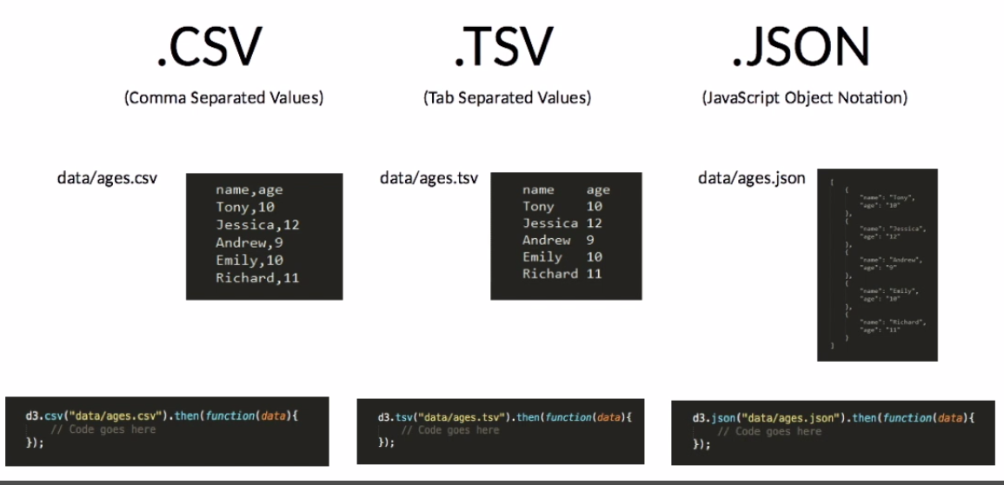

13 – Coding convention

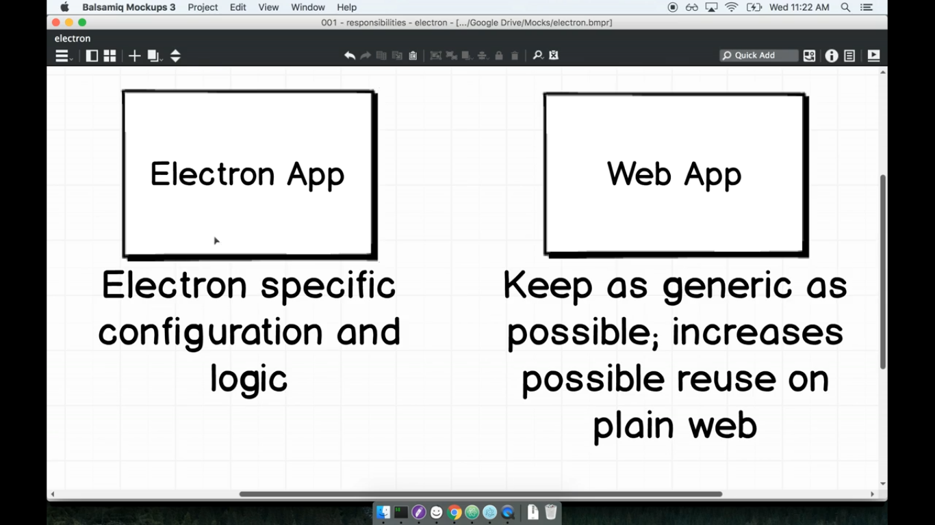

14 – Require is a part of common js module which can be accessed by node js and not react and front end js as it uses import , if we console log require on chrome the we get undefined but if we do that on our electron app , we get result thats becoz our electron app has access to both node modules and also front end modules , so we can use require in script in electron

15 – To pass data from index.html or main window to electron app we use ipcRenderer module
eg -
const electron = require('electron');
const { ipcRenderer } = electron;

16 -
Sending and receiving data from and to electron app and main window methods name

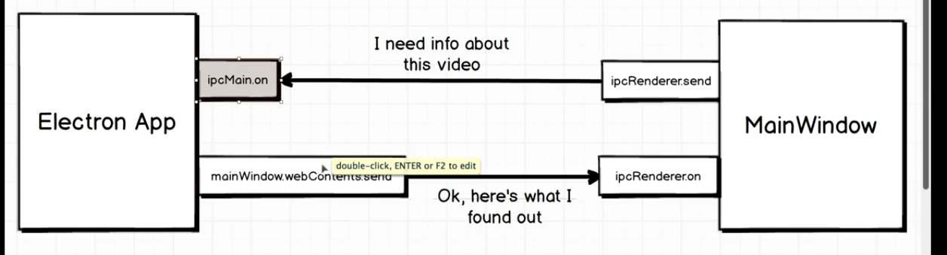

17 – Receive data from index.js or browser window in index.js
first import ipcMain
const {app,BrowserWindow,ipcMain} = electron;

// Then receive data, here videoPath is name of data passed from index.html
ipcMain.on("videoPath",(event,path) => {

});

Here event is event which is fired , this is useful when there are multiple windows and we dont know exactly which window haas fired what
Second parameter is data that is passed

18 – Main Window Scoping
main window should be at top so we can access it in any functions

below require st
let mainWindow;

then use it
app.on('ready', () => {
mainWindow = new BrowserWindow({});
mainWindow.loadURL(`file://${__dirname}/index.html`);
});

19 – When we change something in index.js or electron app , close and re run npm run electron to reflect changes

20 – Building Menues
1 – Import Menu from electron
const { app, BrowserWindow, Menu } = electron;

2 – Create menu template at end in index.js
// Create Menu Template
const menuTemplate = [
{
label: "File"
}
];

3 – Then in app.on method , first set template and then build it
app.on("ready", () => {
mainWindow = new BrowserWindow({});
mainWindow.loadURL(`file://${__dirname}/main.html`);

// Set menu template
const mainMenu = Menu.buildFromTemplate(menuTemplate);
// Build menu
Menu.setApplicationMenu(mainMenu);
});

Note – This method replaces old menu and ability to open developer tools and reload app and quit app

4 – Creating sub menu and osx file name problem
-While creating menues , windos and linux will show correct name of first menu as “File” , but osx will use Electron or name of app , to overcome this problem in osx , add empty object at start of templete , but this way causes empty first menu in windows machine , to overcome such problems , first check which machine is our code running on and then display menues accordingly
-Submenues are created as submenu which is array of objects

eg -
// Create Menu Template and handling osx problem
const menuTemplate = [
{},
{
label: "File",
submenu: [{ label: "New Todo" }]
}
];

To handle it correctly only for osx platform , add below
// Handling osx platform
if (process.platform === "darwin") {
menuTemplate.unshift({});
}

5- Add quit button
accelerator property defines shortcut
Note – accelerator function is immediately invocable
// Create Menu Template
const menuTemplate = [
{
label: "File",
submenu: [
{ label: "New Todo" },
{
label: "Quit",
accelerator:(() => {
if(process.platform === "darwin") {
return "Command+Q";
}
else {
return "Ctrl + Q"
}
})(),
click() {
app.quit();
}
}
]
}
];

Or use ternary operator

const menuTemplate = [
{
label: "File",
submenu: [
{ label: "New Todo" },
{
label: "Quit",
accelerator: process.platform === "darwin" ? "Command + Q" : "Ctrl + Q",
click() {
app.quit();
}
}
]
}
];

6 -
Create a new window on clicking menu
1 – First declare variable at top to avoid scoping issues
eg - let addWindow;
2 – Then create a function to create window
eg -
function createAddWindow() {
addWindow = new BrowserWindow({
width: 300,
height: 200,
title: "Add New Todo"
});
addWindow.loadURL(`file://${__dirname}/add.html`)
}

3 – Add to event
const menuTemplate = [
{
label: "File",
submenu: [
{
label: "New Todo",
click() {
createAddWindow();
}
},

7 – When we close parent window , child window is still open
to avoid that
In main or first window add
mainWindow.on("closed", () => app.quit());

eg -
app.on("ready", () => {
mainWindow = new BrowserWindow({});
mainWindow.loadURL(`file://${__dirname}/main.html`);

mainWindow.on("closed", () => app.quit());

// Set menu template
const mainMenu = Menu.buildFromTemplate(menuTemplate);
// Build menu
Menu.setApplicationMenu(mainMenu);
});

8 – Add developer tools on current active or clicked window only on production

at the end of index.js
if(process.env.NODE_ENV !== "production") {
menuTemplate.push({
label:'View',
submenu:[
{
label:"Toggle Developer Tools",
accelerator: process.platform === 'darwin' ? "Command+Alt+I" : "Ctrl+Shift+I",
click(item,focusedWindow) {
focusedWindow.toggleDevTools();
}
}
]
})
}

9 – Garbage Collection

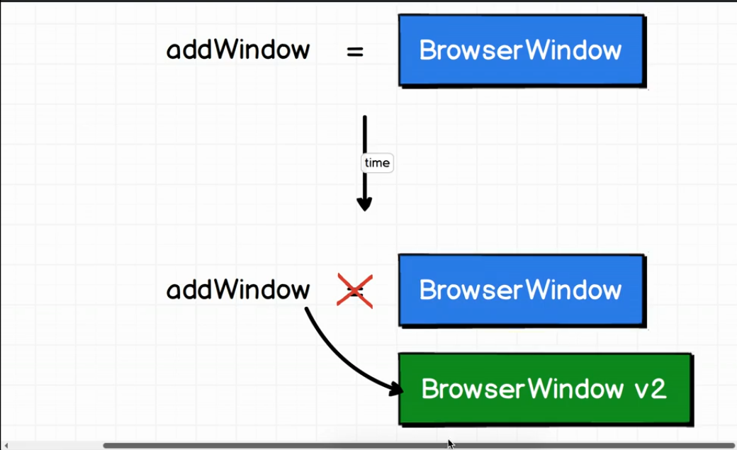

When no variable is pointing to item , js clears that memory
To close window , addWindow.close() does not clears memory,
to garbage collect colsed window 2 ways
first is
ipcMain.on("todo:add", (event, todo) => {
mainWindow.webContents.send("todo:add", todo);
addWindow.close()
addWindow= null
});

second -
When that window is created , add listner
function createAddWindow() {
addWindow = new BrowserWindow({
width: 300,
height: 200,
title: "Add New Todo"
});
addWindow.loadURL(`file://${__dirname}/add.html`);
addWindow.on("closed",() => addWindow = null)
}

10 -Add reload feature
Just add
{role:"reload"},
this is shortcut defined by electron

eg -

if (process.env.NODE_ENV !== "production") {
menuTemplate.push({
label: "View",
submenu: [
{role:"reload"},
{
label: "Toggle Developer Tools",
accelerator:
process.platform === "darwin" ? "Command+Alt+I" : "Ctrl+Shift+I",
click(item, focusedWindow) {
focusedWindow.toggleDevTools();
}
}
]
});
}

11 – Tray
Tray is a tray in upper right corner of ubuntu
BrowserWindow and tray are 2 completly diff things

create a tray
first import tray
const { app, BrowserWindow , Tray} = electron;

second create new instance of tray
app.on("ready", () => {
mainWindow = new BrowserWindow({
height:500,
width:300,
frame:false,
resizable:false
});
mainWindow.loadURL(`file://${__dirname}/src/index.html`);
// Create tray instance
new Tray();
});

third create icon path by importing first path module (Here we use path module because path module takes two path and joins them based on current os syntas ie forward or backward slash)
app.on("ready", () => {
mainWindow = new BrowserWindow({
height:500,
width:300,
frame:false,
resizable:false
});
mainWindow.loadURL(`file://${__dirname}/src/index.html`);

const iconPath = path.join(__dirname,'./src/assets/iconTemplate.png')
// Create tray instance
new Tray(iconPath);
});

12 – Hide top menu
app.on("ready", () => {
mainWindow = new BrowserWindow({
height:500,
width:300,
frame:false,
});

13 – dont allow user to resize window
app.on("ready", () => {
mainWindow = new BrowserWindow({
height:500,
width:300,
frame:false,
resizable:false
});

14 – Tray , functionality to click on tray icon and show our app , and show it only when user click icon and not on start

first hide app on start
app.on("ready", () => {
mainWindow = new BrowserWindow({
height:500,
width:300,
frame:false,
resizable:false,
show:false <---------------------------
});

show app on clicking tray icon

const electron = require("electron");
const path = require('path')

const { app, BrowserWindow , Tray} = electron;

let mainWindow;
let tray; <-----------------------------------

app.on("ready", () => {
mainWindow = new BrowserWindow({
height:500,
width:300,
frame:false,
resizable:false,
show:false
});
mainWindow.loadURL(`file://${__dirname}/src/index.html`);

const iconPath = path.join(__dirname,'./src/assets/iconTemplate.png')
// Create tray instance
tray = new Tray(iconPath); <-----------------------------
tray.on("click",() => { <------------------------------
mainWindow.show()
})
});

15) Toggle App
const electron = require("electron");
const path = require('path')

const { app, BrowserWindow , Tray} = electron;

let mainWindow;
let tray;

app.on("ready", () => {
mainWindow = new BrowserWindow({
height:500,
width:300,
frame:false,
resizable:false,
show:false
});
mainWindow.loadURL(`file://${__dirname}/src/index.html`);

const iconPath = path.join(__dirname,'./src/assets/iconTemplate.png')
// Create tray instance
tray = new Tray(iconPath);
tray.on("click",() => {
if(mainWindow.isVisible()) { <-------------------------------------------
mainWindow.hide();
}
else{
mainWindow.show()
}
})
});

16) Make tray position in upper right

We use bounce to position and size window

17) Install redux dev tools
yarn add electron-devtools-installer -D
add below in electron main file
const {
default: installExtension,
REDUX_DEVTOOLS
} = require("electron-devtools-installer");

and put below line in app.on ready after
mainWindow = new BrowserWindow({ width: 800, height: 600 });

installExtension(REDUX_DEVTOOLS)
.then(name => console.log(`Added Extension: ${name}`))
.catch(err => console.log("An error occurred: ", err));

18 – Pdf printing logic
main window -
// Pdf printing
ipcMain.on("print-to-pdf", function(event) {
// First Create a directory manually called outputpdf
const pdfPath = path.join(__dirname, "/outputpdf/print.pdf");
// Get window which is sending event
const win = BrowserWindow.fromWebContents(event.sender);
// Print pdf
win.webContents.printToPDF(
{ printBackground: true, landscape: true },
function(error, data) {
if (error) throw error;
fs.writeFile(pdfPath, data, function(error) {
if (error) {
throw error;
}
// Open pdf after saving it to disk
shell.openExternal("file://" + pdfPath);
});
}
);
});

browserwindow -
Here made with react -
export default class ResumeTemplate extends Component {
printHandler = () => {
ipcRenderer.send("print-to-pdf");
};

